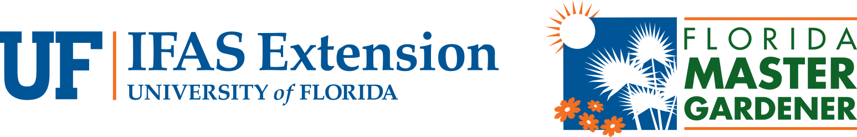
ID or Name (use the same one for Pre and Post test)
KEY
2018 Turfgrass Field Day POST-TEST
1. What are two major diseases affecting St. Augustinegrass this year?
A LARGE PATCH B TAKEALL ROOT ROT
2. What are two plant characteristics being selected for in the UF St. Augustinegrass breeding program?
A. Drought Resistance B Disease Resistance

3. Which of the following is NOT a cultural pest management strategy for residential lawns?
a. Host plant resistance
b. Increasing plant diversity
c. Using biorational or natural pesticides
d. Proper irrigation and fertilization

4. What are two symptoms of nematode damage in turfgrasses?
A. Yellowing B. Decline (also wilting, browning, thinning)
5. What nitrogen source would be best to use before a 4 month summer fertilizer ban?
a. Water soluble
b. Sulfur coated urea
c. Polymer coated
d. Biosolid

6. It is permissible to apply what nutrients during a fertilizer ban period?
a. Phosphorus
b. Sulfur
c. Potassium
d. Micronutrtients

7. Why does soil compaction effect turf health? Roots cannot penetrate the soil to access nutrients and water.

